**Classification of living organisms**  
Classification key – Activity

**Use a classification key to identify these living things.**

Write the name of each organism below in the corresponding box.

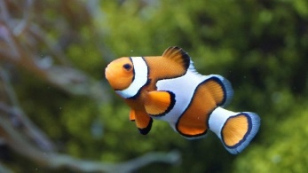 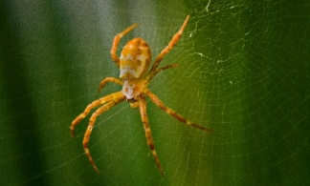

Parrot Sunflower Clownfish Spider

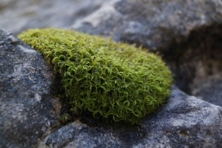 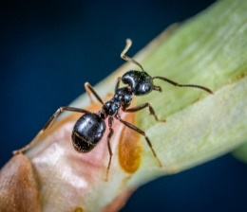

Moss Ant Iguana Cow

Can it move from one place to another?

**YES**

**NO**

**NO**

**YES**

Has it got flowers?

Has it got bones inside its body?



**YES**

**NO**

**NO**

**YES**

Has it got 8 legs?

Does it produce milk?

**YES**

**NO**



Has it got wings?

**YES**

**NO**



Can it breathe underwater?

**NO**

**YES**

