Analytical tour

Analytical lab tour – teacher manual

Introduction
A number of applied school science courses recommend that students should make a site visit to some aspect of the chemical industry. Such visits are often difficult to organise and some areas are almost impossible to get access to. Major constraints on organising visits to laboratories, pilot plants or production sites are time, space, safety and compliance with Good Manufacturing Practice. Visitors are prohibited in some areas when active large scale chemistry is underway and therefore planning visits weeks in advance becomes impracticable.
To partly address the needs of applied science courses and some A-level chemistry courses, virtual visits of the chemistry laboratories and pilot plant on a pharmaceutical company’s sites has been created. Although students can navigate round them at leisure, there may be benefits from them being teacher led using a projected image from the web site. Questions are also provided to enhance the learning experience.

On-screen text from the virtual tour of an analytical chemistry laboratory
The text that appears in the info box on screen is reproduced here. Additional text is in italics. Questions and discussion points are in boxes within the text at appropriate places.
Picture of general lab view 1
The analytical chemistry laboratories play important roles in the drug discovery process. The equipment is used to check the structures of new chemicals that are made in synthetic labs. Most synthetic chemists can interpret their own spectra, but for complex problems the analytical chemists can solve them using a combination of techniques. They also investigate by-products formed when chemical reactions are done in a bigger scale. Another crucial role is to check the purity of products made on a large scale which are destined for trials in patients.
Picture of general lab view 2
The techniques used in this laboratory have complicated names which are usually abbreviated. NMR is used to look at the nuclei of atoms and can “see” the relative positions of hydrogen and carbon atoms in molecules. Mass spec measures the molecular weight (formula mass) of molecules and is usually used in conjunction with HPLC which is used to separate mixtures and check purity. Other techniques that are regularly used are GC for analysing volatile compounds and ICP for measuring trace amounts of elements. UV and IR are rarely used as they are not very sensitive.

NMR | nuclear magnetic resonance spectroscopy (also used for fluorine, nitrogen and phosphorus)
mass spec | mass spectrometry
HPLC | high performance liquid chromatography
GC | gas chromatography
ICP | inductively coupled plasma spectrometry
UV | ultra violet spectroscopy
IR | infra red spectroscopy

Picture of magnetic field warning sign
The protection of chemist from the hazards of doing practical chemistry is very important. Safety spectacles and lab coats are always worn in the laboratory. NMR machines in many analytical chemistry labs produce very high magnetic fields. Provided basic safety rules are observed this is not a problem. However strong fields can disrupt heart pacemakers fitted to people with heart problems.
The magnets of modern machines are shielded by an external opposing field to reduce the hazard. Furthermore, magnetic field strength drops off rapidly as you move away from a magnet (strength is inversely proportional to the square of the distance) making the hazard in the working area very low.

Virtual tour
The laboratory for this tour is a large room. The panoramic camera was placed a little off-centre. The notes below go left to right round the various features.
NMR - Nuclear Magnetic Resonance – general comments – click on other machines for more detail.
NMR allows chemists to “look” at individual atoms in a molecule. It is mostly used for hydrogen atoms (¹H) but others are commonly looked at (¹³C, ¹⁵N, ¹⁹F, ³¹P). A solution of the sample is put into a very strong special magnet and the atoms are excited using a short burst of radio energy. The excited atoms then give out energy which is converted into a spectrum that can be used to determine the structure of the molecules in the sample.
Download documents are available for a more detailed background to NMR, plus an exercise on interpreting NMR spectra. Most Year 12/13 students can match the structures with the spectra in this exercise within half an hour.

Anna-Maria
The lab bear is called Anna-Maria. She oversees the lab at night. The bear is named after an Industrial Placement student who spent a year working in the analytical team as part of her degree course acquiring in-depth knowledge about spectroscopy. During the year, the enterprising student collected “bear” tokens from boxes of tissues - she ran a lot of spectra as well!
Solvent cupboard
A steel lined cupboard is used for the safe storage of solvents. Some are flammable. Many litres of solvent are required for the HPLC equipment but less than 1ml for NMR. NMR can see all of the hydrogen atoms in a sample including those from the solvent which would swamp the signals of interest. By replacing all the hydrogen atoms in the solvent with deuterium (²H – an isotope of hydrogen) it allows you to see just the signals of the sample.
Deuterium does give an NMR spectrum but in a completely different “place”. All atoms/isotopes with an odd number of protons and/or neutrons can theoretically give an NMR spectrum. Common solvents are:
deuterated chloroform CDCl₃ and deuterated dimethylsulphoxide (CD₃)₂S=O

Class discussion point:
What is the atomic structure of a deuterium atom?
What is the relative molecular mass of the gas that is produced when deuterated water D2O, also known as “heavy water”, reacts with sodium?

Door to service corridor.
All the supplies of solvents and chemicals are delivered by stewards via a central service corridor in the building. Stewards also take away waste for incineration. Chemists use this route to move their chemical samples about too. The main pipes for nitrogen, vacuum and water services which go to all of the fume cupboards are run down this corridor and are easily accessible by service engineers.
Gas Chromatography (GC) click the equipment to see inside
This equipment is a GC. It is similar to HPLC but the sample is turned into a gas and forced down a narrow silica capillary tube 10-25 meters long (gold coloured) using hydrogen or helium. The capillary tube is inside an oven. An HPLC column is packed with powdered silica, but the GC column is hollow and coated on the inside with a thin layer of polymer which the sample interacts with. GC is mainly used for separating out mixtures of volatile chemicals and determining their purity.
Fume cupboard
All chemical samples are handled in a fume cupboard. When a chemist is not working there the front sash is closed to prevent the air conditioned lab air being lost to the outside environment. When the sash is open the airflow is 0.5 meters per second. The area of a fully open sash is about 1 m² so about 0.5 m³ of air is drawn through per second. This stops the chemist from breathing in hazardous vapours from solvents and chemicals in use.
Freeze drier
Drying an aqueous mixture requires lengthy boiling at 100°C. This can be a big problem for small quantities of valuable samples which might decompose on heating. This unit freezes the water in the solution under a high vacuum. At low temperature and pressure, water converts straight from a solid into a gas – a process known as sublimation. The sample then ends up completely dry. Instant coffee powder is made this way.
Fridge
Used for storing samples so that they do not decompose over time. Roughly, a 10°C fall in temperature halves the rate of a chemical reaction. Therefore a sample stored at 4°C in a fridge would take 4 times longer to break down than if it were stored at a room temperature of 24°C. That’s why milk keeps for 4 days in a fridge and only one day on a window ledge.

Class discussion point:
Old style pressure cookers heat water above its normal boiling point to roughly 120°C. In an ordinary pan it takes about 20 minutes to boil potatoes. How long do they take in a pressure cooker?

Class discussion point:
The silica used in the column is a very fine powder. It is so fine that it “clogs” the tube and so the solvent needs to be pushed through it at high pressure. It would be a lot easier to use larger particles of silica that were, say, sand sized. Why does the silica need to be so fine?

NMR - Nuclear Magnetic Resonance – Magnet
A general background to NMR is given as the text that goes with the large machine (see later).
When a sample is put in a strong magnetic field some atoms can “line up” like compass needles. One of the strongest magnetic fields possible is made using special coils of wire kept at -269°C using liquid helium. This is kept cold with an insulated jacket of liquid nitrogen at -196°C. At this very low temperature the coils become superconductors and electrons flow around the electromagnetic coil indefinitely without resistance. No heat is generated.
The liquid nitrogen is topped up once a week (it is cheap) and the liquid helium very infrequently (it is expensive).

Class discussion point:
What are the approximate boiling points of liquid helium and liquid nitrogen on the Kelvin scale?

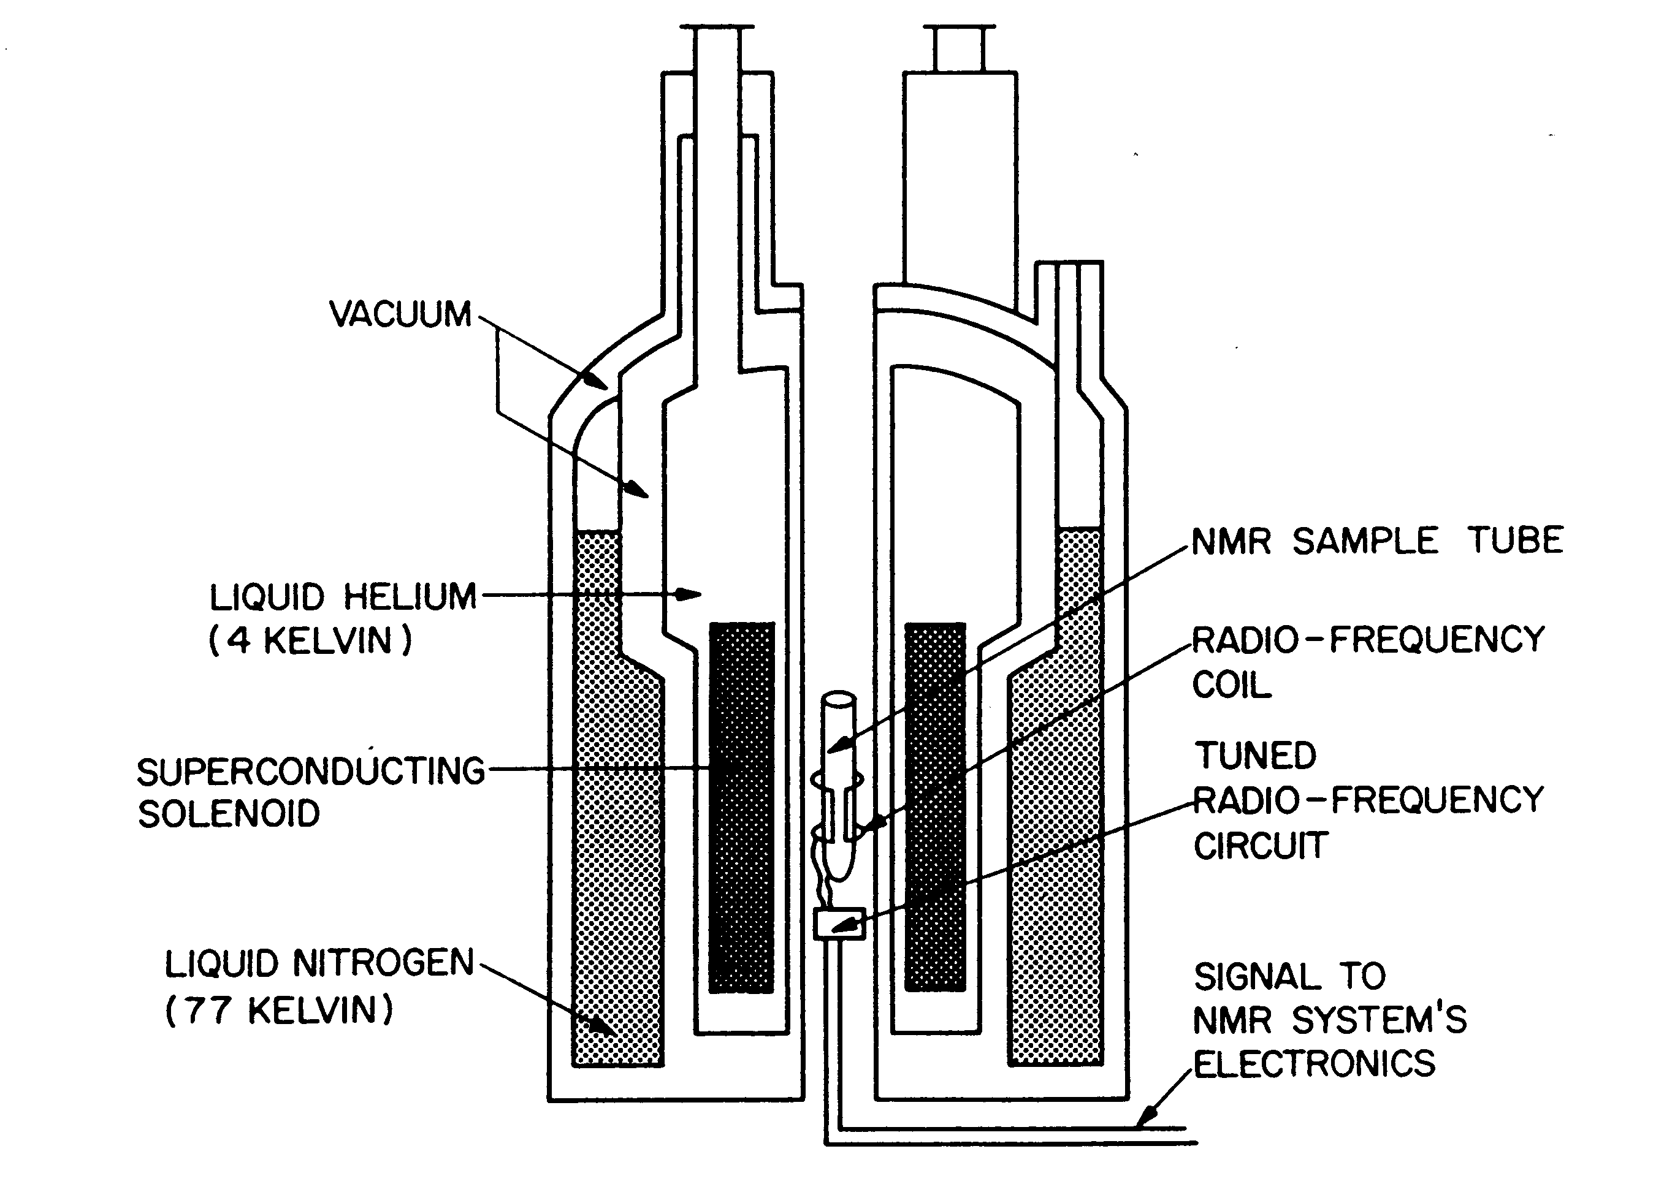
NMR - Nuclear Magnetic Resonance – Automated sample changer
Up to 60 samples can be placed in a carousel. A robotic hand picks them up and drops them very gently on a cushion of nitrogen into the centre of the magnet. It is important that the powerful and focussed magnetic field is not affected by external influences. The sample changer is therefore made from non-magnetic materials and all of the operations are powered by compressed nitrogen gas.
NMR - Nuclear Magnetic Resonance – Electronics
This box contains most of the electronics used to run the NMR machine. It has a radio frequency generator connected to coils around the sample to excite some of the protons of the hydrogen atoms up to a higher unstable energy state. After a few microseconds the energy is turned off and the excited atoms give out energy which is picked up by the same coil, this time acting as an aerial. A computer turns the complex signal into a spectrum.
All of the excited atoms give out energy at the same time as a set of overlapping sign waves (it looks a mess graphically!). By using Fourier transformation, the complex signal can be split up into its individual sign waves and these are manipulated to give a spectrum of separate peaks. The transformation is analogous to ringing a bell. It gives out a set of sign waves which are equivalent to a series of individual tuning forks.
NMR - Nuclear Magnetic Resonance – Console
The spectrum is displayed on the screen once the software has transformed the complex signal from the sample. The spectrum can be manipulated in a number of ways to give three important pieces of information. It tells you what different types of hydrogen atoms are present; how many of each type there are; and how many other hydrogens are on adjacent carbon atoms. The console is also used to fine-tune the radio coils.
NMR - Nuclear Magnetic Resonance – Safety fence
The powerful magnetic fields in this lab can affect watches and credit cards. A greater hazard is that a strong field can disrupt heart pacemakers fitted to people with heart problems. This fence indicates the safe area outside the magnetic field. Large steel objects e.g. spanners, are not allowed near the magnet. They will disrupt the magnetic field, create heat in the wire coils and the liquid gases may boil off which could asphyxiate staff.

Answers to questions
What is the atomic structure of a deuterium atom?
What is the relative molecular mass of the gas that is produced when deuterated water D₂O, also known as “heavy water”, reacts with sodium?
One proton, one neutron and one electron.
4
Old style pressure cookers heat water above its normal boiling point to roughly 120°C. In an ordinary pan it takes about 20 minutes to boil potatoes. How long do they take in a pressure cooker?
5 minutes
The silica used in the column is a very fine powder. It is so fine that it “clogs” the tube and so the solvent needs to be pushed through it at high pressure. It would be a lot easier to use larger particles of silica that were, say, sand sized. Why does the silica need to be so fine?
For a fixed mass of any solid, the surface area of a fine powder is many times greater than larger grains. Chromatography depends upon the solute adsorbing onto the surface of the silica. The greater the surface area, the greater the efficiency of separating mixtures. Refer to the download for more details about the structure of the silica.
What are the approximate boiling points of liquid helium and liquid nitrogen on the Kelvin scale?
Helium: 4K
Nitrogen 77K

