Classification of living organisms
Work like a scientist!

Part 1 – Observe each animal below and complete the table with your findings.
Tick the box if the animal has the indicated feature. The first four rows have already been filled in as examples.

 | Robin  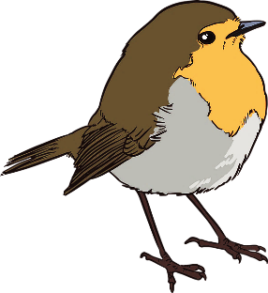 | Squirrel  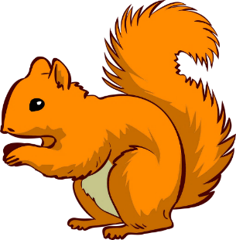 | Dog (Rottweiler)  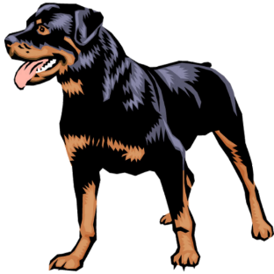
Can fly
Can climb trees
Lay eggs
Have live babies
Feathers
Hair
Beak
Snout
Pointy ears
Hanging ears

Part 2 – Create a classification key based on your observations.
- Think about 2 questions based on your previous findings to classify these animals.
Write them in the grey boxes.
- Write the name of each animal in the corresponding white box.

NO
YES
NO
YES

Robin Squirrel Dog (Rottweiler)

