Balanced Diet
Unscramble
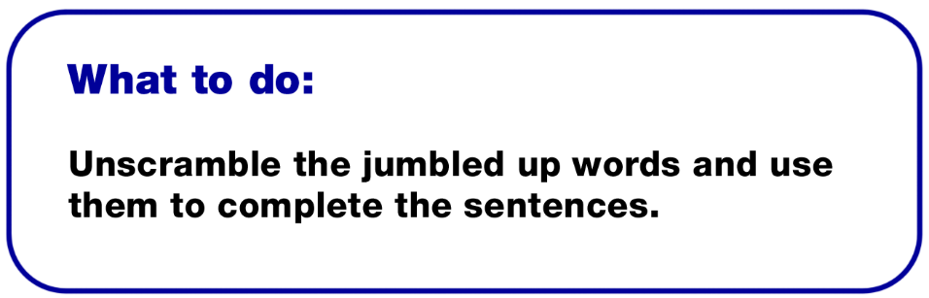

Sentence Word

- -------------- is needed to keep food flowing smoothly
through the digestive system. hggoarue

- Small amounts of -------------- are needed for the blood,
bones, teeth and nerves. renmalsi

- -------------- are found in bread and cereals and provide
energy. athorcydsabre

- -------------- are found in butter, margarine and oils and
are a source of energy. atfs

- -------------- is essential for all life. etraw

- --------------are used for body repair and growth. entipsor

7. -------------- help everything in the body to work properly. mistavin

