Automated lab tour

Automated chemistry lab tour – teacher notes

A number of applied school science courses recommend that students should make a site visit to some aspect of the chemical industry. Such visits are often difficult to organise and some areas are almost impossible to get access to. Major constraints on organising visits to laboratories, pilot plants or production sites are time, space, safety and compliance with Good Manufacturing Practice. Visitors are prohibited in some areas when active large scale chemistry is underway and therefore planning visits weeks in advance becomes impracticable.
To partly address the needs of applied science courses and some A-level chemistry courses, virtual visits of the chemistry laboratories and pilot plant on a pharmaceutical company’s sites has been created. Although students can navigate round them at leisure, there may be benefits from them being teacher led using a projected image from the web site. Questions are also provided to enhance the learning experience.
To see some robots doing automated chemistry and some of the techniques used in Combinatorial Chemistry, view the video on the RSC’s Alchemy? CD:
http://www.rsc.org/Education/teachers/resources/Alchemy/index2.htm

On-screen text from the virtual tour of the automated chemistry laboratory.
The text that appears in the info box on screen is reproduced here. Additional text is in italics. Questions and discussion points are in boxes within the text at appropriate places.
Automated chemistry laboratory tour: introductory text
The goal of a pharmaceutical R&D organisation is to make a new chemical compound which has the right biological activity to be used in a medicine to treat patients. A crucial step in the process is to identify a “lead compound”. This is a compound which interacts with the target biological receptor or enzyme and can act as a starting point for discovering a series of compounds which have the perfect biological profile. In this automated chemistry lab, the scientists make, analyse and purify tens of thousands of compounds for biological testing. By using automated equipment and developing efficient processes, the scientists can increase the number and quality of the compounds prepared.
The concept of diversity and fitting molecules into receptor topology
To maximise the chances of success we test as may compounds as possible against the biological target. The compounds that we test must be as different as possible from each other to create “diversity”. In simple terms, if we tested 10,000 different square shaped molecules we would never get a lead for a biological target that has a triangular shaped receptor site. Following this analogy, it is better to test 1000 compounds in which the molecules are “triangles”, 1000 “squares”, 1000 “pentagons” etc. That way we are likely to pick up the “triangle” and optimise the biological action by making “triangular” compounds related it.
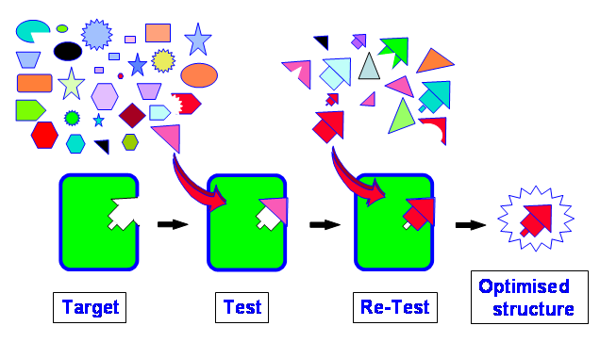

The concept of combinatorial chemistry using esters as an example
To create a large numbers of diverse compounds is very slow and laborious to make each one by hand. That is why we use robots that can do the same chemical reaction over and over again but using different starting materials.
For example, think about the preparation of 96 different esters. An ester is made by reacting an acid with an alcohol. By reacting 8 acids with 12 alcohols we would get 96 different esters.

The concept of using a matrix for making 96 different esters
The robots usually carry out reactions in racks of “test tubes” in an 8 x 12 matrix. The robot would be programmed to dispense Acid 1 to the 12 tubes in row 1; Acid 2 to the 12 tubes in row 2 etc. up to row 8. It would then put Alcohol A into the 8 tubes in column A; Alcohol B into the 8 tubes in row B etc. up to column 12. Once the chemicals have reacted we would end up with 96 different esters. [A catalyst or dehydrating agent would also be added to make the reaction work.]
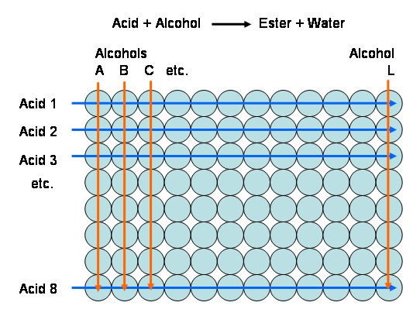

Task: ICT is used to bar code the reaction matrix which, in practise, is a 12x8 rack of tubes. If a simple chemical reaction is being carried out in every tube it is very easy to work out the relative molecular mass (M_{r}) of the product since you know the relative molecular masses of the starting materials. If it is an addition reaction, the M_{r} of the product is the sum of the M_{r} of two starting materials. If it involves the loss of water then the product is the sum of the M_{r} of the starting materials minus 18.
Set up a spreadsheet to calculate the relative molecular masses of 96 esters formed from 8 acids (1 to 8) and 12 alcohols (A to L) using a simple increasing homologous series, e.g.:
1. CH₃CO₂H; 2. CH₃CH₂CO₂H; 3. CH₃CH₂CH₂CO2H etc
A. CH₃OH; B. CH₃CH₂OH; C CH₃CH₂CH₂OH etc
The method is relatively easy and requires only an awareness that the chemistry involves a dehydration (-18) between the acid and alcohol.
The relative molecular masses of acid 1 and alcohol A are 60 and 32 respectively. The ester derived from them therefore has a relative molecular mass of 74 (60 + 32 – 18).
In a spreadsheet, 74 is entered into cell A1. Since the next acid B and alcohol 2 are homologous with A and 1, the relative molecular masses increase by 14 (CH₂). Therefore the formula =A1+14 is entered into cells A2 and B1. Use the fill handle to copy this formula across all cells.

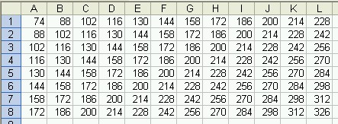
Spreadsheets for much more complicated examples can also be created but you have to be very careful in using the fill handles to copy formulae from cell to cell.
The standard preparation of aspirin involves the reaction of a phenol with an acid anhydride.
The relative molecular masses (M_{r}) are:
Phenol 138; anhydride 102; product 180
An understanding of the chemistry shows that the M_{r} of the product is the sum of the M_{r} of the phenol minus one (loss of H), plus the M_{r} of the ethanoyl group (anhydride M_{r} minus 16 (loss of O) divided by two).
This can be express by a spreadsheet type formula:
= (anhydride M_{r} – 16)/2 + phenol M_{r} -1
Without worrying about specific structures, the relative molecular masses of a series of phenols and anhydrides can be entered into cells A1-M1 and B2-B9 as shown:

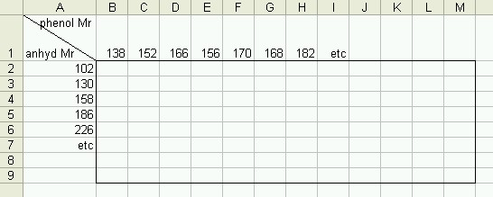

A spreadsheet which calculates the relative molecular masses of the products of a set of similar reactions can be created as follows:
1. The formula =(A2-16)/2+B1-1 is entered into cell B2 (gives 180)
It is not easy to copy/transpose this formula into other cells so that it picks up Row 1 and Column A values. Therefore it is better to base the calculation on the neighbouring cells as follows.
2. The formula =B2+(A3-A2)/2 is entered into cell B3 (gives 194 and takes into account the increase in M_{r} of A2 to A3
3. The fill handle of B3 is used to drag the formula through cells B4 to B9
4. The formula =B2+C1-B1 is entered into cell C2 (gives 194 and takes into account the increase in M_{r} of C1 to B1
5. The fill handle of C2 is used to drag the formula through cells D2 to M2
6. The formula =B3+C2-B2 is entered into cell C3 (gives 208 and takes into account the increase in M_{r} of C1 to B1 which is the same as C2 to B2)
7. The fill handle of C3 is used to drag the formula through cells C4 to C9
8. This is repeated for all columns down from D3 to M3

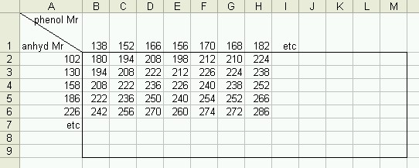

It is not important what the starting materials are, but for interest, the relative molecular masses for A2 to A6 and B1 to H1 are for the following compounds (using common abbreviations). Isomeric variations could also be considered.
A2 to A6: (MeCO)₂O; (EtCO)₂O; (PrCO)₂O; (BuCO)₂O; (PhCO)₂O
B1 is 2-hydroxybenzoic acid and C1 to H1 have the substituents:
4-Me; 3,4–diMe; 5-F; 4-Me-5-F; 4-MeO; 4-MeO-5-Me
Students could be asked to draw the structure of the product in H6 and confirm the relative molecular mass. What is the M_{r} of the by-product?

View of laboratory
The work is carried out by a team of scientists with different areas of expertise. Medicinal chemists decide which molecules to prepare and carry out the synthesis. Software programmers write scripts to enable the transfer of lots of data and to help the chemists design the molecules. Other scientists set up the robots to synthesise the compounds. Analytical chemists set up the equipment and methods to check the quality and to purify the compounds. The robots are housed in ventilated cabinets to ensure that the scientists are not exposed to any chemicals. When they first try out the reactions which will be used by the robots, the chemists prepare the compounds manually in fume cupboards.
Conclusion
In this tour we have created a montage of the various pieces of automated equipment used to carry out high throughput chemistry; from automated weighing of sample bottles and reaction robots to automated purification systems. The equipment is not necessarily all in the same area, but the montage is presented as a linear sequence in the order of how the processes are carried out.
Virtual tour
Automated chemistry robots
The robot can carry out many different operations. It is essentially a set of hollow needles connected to syringes and stock bottles of chemical reagent solutions. The syringes are programmed to suck up accurate volumes of solutions and add them into specific reaction tubes. Typically there will be 96 tubes in an 8x12 rack and 96 similar reactions will be done at once. For example 96 esters can be made from a matrix of 12 alcohols and 8 acids.
To see some robots doing chemistry and some of the techniques used in Combinatorial Chemistry, view the video on the RSC’s Alchemy? CD.
http://www.chemsoc.org/networks/learnnet/alchemy.htm
Vacuum centrifuge – click to look inside
After the chemical reaction, the products are obtained as a solution. It is difficult and slow to boil off the solvent from lots of sample tubes. Imagine doing 96 distillations. By doing the evaporation under a partial vacuum the solvent’s boiling point is lowered and it is quick. The problem is that the vacuum tends to make liquid “jump out” of the tubes as the solvent boils off. To stop this, the tubes are spun in a centrifuge to hold the solutions down.
Racks of impure reaction products
Once the chemical reactions have been done, a few simple tasks are used to remove by-products and waste; e.g. adding alkali to neutralise acids, filtration to remove solids. These operations can all be done by a robot for each of the 96 reactions. The impure products end up dissolved in a solvent in small tubes which are stored in these racks. A robotic arm removes them one at a time and injects the contents into a HPLC machine to purify them.
High performance liquid chromatography (HPLC).
HPLC is used to purify reaction products. It is similar to paper chromatography that is used for separating inks by running them up filter paper in water. In HPLC, the mixture of chemicals from a reaction is injected onto one end of a steel tube packed with silica (SiO₂) and separated by pushing solvent through the tube at high pressure. HPLC is a very important technique and this unit automatically purifies the products of 4 reactions at a time.
Mass spectrometer – used to measure molecular weight (formula mass)
Modern mass spectrometers are fairly small. This one is connected to a multiple channel HPLC unit. As pure components of a mixture come off the end of one of the HPLC columns a tiny portion is injected into the mass spectrometer. Molecules in the sample are converted into charged ions using a low energy method which does not break up the molecules. Their molecular weight is calculated from the time taken by the ions to pass along an electrostatic field.

Purified sample collection unit
As a mixture is separated on an HPLC column, the solution coming off the end of the column is analysed by a mass spec. This gives the molecular weight of each component of the original mixture. We only need to save the solution containing the chemical with the molecular weight that we want. This robot sends solutions of the pure products into specific pre-weighed tubes and sends the rest to a waste can. ICT tracks which product is from which original reaction.
Blow down unit
Solvent must be removed from the solutions before weighing the pure products. For solutions of 15-25 ml in each tube, the best way is to blow the solvent away using nitrogen gas. It is just like drying clothes outside – water evaporates faster on a windy day. In this unit, nitrogen gas is blown over the tops of the solutions in each of 96 tubes. After use, the nitrogen and solvent vapours are chilled to freeze out the organic solvents for disposal by burning.
Automated weighing robots
The robot arm picks up sample tubes one at a time from the trays on the left. The bar-code on the tube is read by a laser. The balance cover slides open. The tube is placed on the balance pan, the cover is closed and the tube’s mass recorded. The cover opens again and the robot arm puts the tube back in the 8x12 tray noting its position. The tubes are first weighed empty and later when they contain samples. The mass of each sample is then calculated automatically.
Liquid handling robot 1
The mass of the pure product in each tube is known from the automated weighing robot. The molecular weight of the product in each tube is also known from earlier mass spectrometry and so a simple calculation works out the number of moles. This robot can be used to add exactly the right volume of storage solvent to each of the 96 tubes to give a standard concentration, e.g. 0.01 mol dm⁻³. The robot can also be used to transfer solutions to smaller tubes.
Task
Refer to the matrix of reactions for producing analogues of aspirin and think about the reaction between phenol H and anhydride 6.
If 18.2 mg of H and 22.6 mg of 6 produce 15 mg of pure product H6:
1. What is the chemical yield of the reaction? 52%
2. How many moles of product H6 were produced?
0.0000524 moles ( = 0.015 / 286)
3. How much solvent has to be added to make a 0.01 mol dm⁻³ solution?
0.01 mol dm⁻³ = 0.01 moles per 1000ml
For an equivalent concentration, 0.0000524 moles has to be dissolved in x ml
x = 1000 x 0.0000524 = 5.24 ml
0.01

Liquid handling robot 2
This robot delivers small volumes of solutions of purified compounds into 96 well plates which are stored in racks. From tests performed in these plates, the relative solubility of the compounds in water and in oil is calculated. This ratio gives a good indication of whether a potential drug can cross a mammalian cell membrane. The ratio is called the partition coefficient.

