Scaling up - information

Scaling-up a chemical process

Over the years one A-level chemistry course has provided two different experimental procedures of how to synthesis aspirin in the school laboratory. They both are successful but both have pros and cons.

Activity 1
Aim
Consider both procedures and decide which would be the most suitable for carrying out on 10,000 times the scale on a pilot plant as opposed to the 2g lab scale. Are they equally good or does one have significant problems?

Procedure A.

1. Weigh out 2g of 2-hydroxybenzoic acid and place it in a conical flask. (The starting material is an irritant fluffy white solid).
2. Add 4cm3 of ethanoic anhydride and agitate to mix the 2 chemicals. (The anhydride is a colourless liquid with a pungent smell of vinegar).
3. Add 5 drops of concentrated sulphuric acid (hazardous viscous liquid – causes burns) and continue agitating the flask for 10 minutes. Crystals of aspirin will be produced and form a crystalline mush.
4. Dilute by adding 4cm3 of cold glacial ethanoic acid and cool in ice.
5. Collect the crystals using vacuum filtration and wash once with cold water.
6. Recrystallise the product from water. Dry and weigh the product.

Procedure B.

1. Weigh out 2g of 2-hydroxybenzoic acid and place it in a pear shaped flask. (The starting material is an irritant fluffy white solid).
2. Add 4.0 cm3 of ethanoic anhydride (a colourless liquid with a pungent smell of vinegar).
3. The reaction mixture will get slightly warm so cool it by swirling the flask under running water.
4. When cool, add 2 anti-bumping granules.
5. Heat under reflux for 30 minutes.
6. Cool the mixture.
7. Pour into 100cm3 of cold water containing 10cm3 of dilute sulphuric acid. Stir and allow the resulting suspension to stand for 15 minutes.
8. Filter off the crystals that form. Dry and weigh the product. Recrystallise if required

Activity 2
How could Procedure B could be scaled up 10,000 times the scale to 20kg of starting materials?

The typical school preparation would probably use a reflux apparatus of the type shown below using a Bunsen burner to heat it. Vacuum filtration would be used to isolate the product.

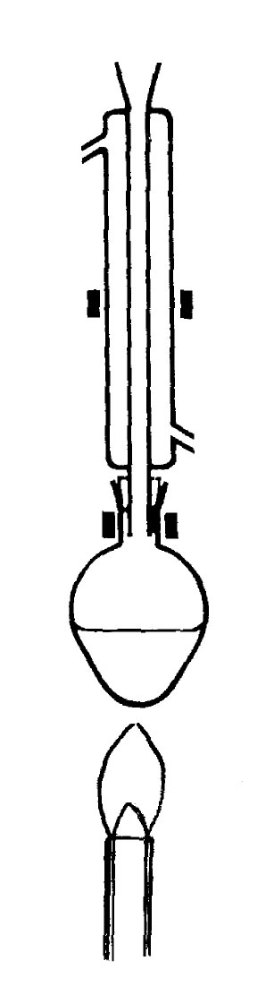 | 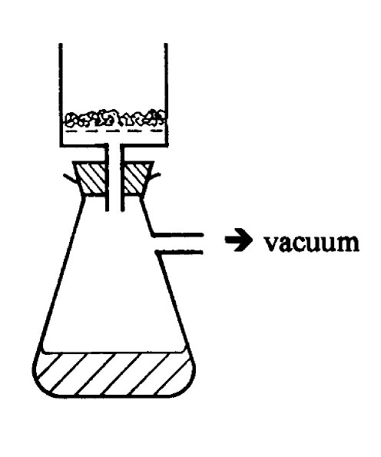
Think about every operation in this procedure and work out how you would do each phase of the reaction on 10,000 times the scale i.e. starting with 20kg of the 2-hydroxybenzoic acid. Safety and protection of the environment are always the most important things to consider. Work out how you would weigh 20kg of an irritant fluffy powder. Decide how you could cool and heat the reaction and then how to filter off the product. Don't forget - the product is designed to be biologically active - you can not ignore the potential hazards of the product nor how to dispose of any waste materials from the process.

The material being made is going to be taken as a medicine. It must be pure.

Draw the apparatus that you think you could use to carry out the operations and describe each step. Remember that you can not lift apparatus once you get to that size and you should try to do as much as possible in one vessel. Think about how to do every step safely. Think about how you would clean the apparatus for the next set of reactions. Think about costs - what are the costs and how might they be minimised?

Once chemists have worked out how to make a drug safely and effectively on a 20kg scale it is relatively "easy" to scale the reaction up further. Aspirin is made in batches of 6000kg at a time. That's enough for 20 million tablets!

How would you do each phase of the reaction on a 20kg scale?

Draw the apparatus you would use in the space at the side. Make notes below. Think about everything you need to do first. Try to minimise the amount of equipment used and make it versatile so that it can be used for other reactions. Consider safety. Fire is one of the biggest hazards; naked flames and electric heaters and motors are banned.
Step 1:
Weigh solid

Step 2:
Measure & add liquid

Step 3:
Swirl & cool flask

Step 4:
Add anti-bumping granules

Step 5:
Reflux

Step 6:
Cool

Step 7:
Pour into water

Step 8:
Filter & dry the product

