Hazard symbols

The safety of a workplace is increased by the presence of safety signs. There is a standard for sign design and so everyone recognises them easily. New international signs are gradually being introduced – both are shown below.

Task: Match the Hazard symbols to their meaning:
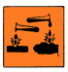 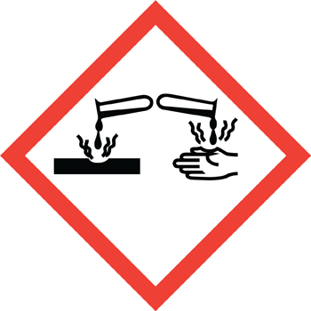 Toxic
 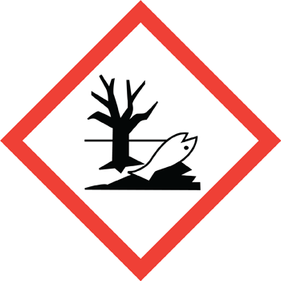 Irritant
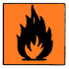 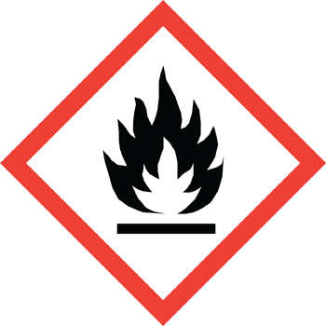 Flammable
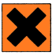 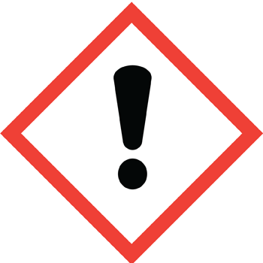 Oxidising
 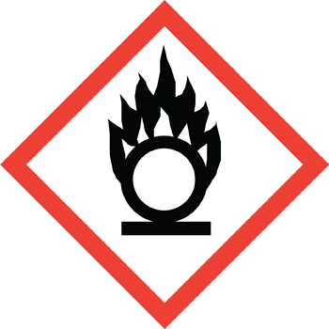 Dangerous for the Environment
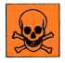 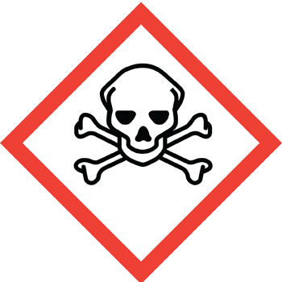 Corrosive

